**GuviTask4 Outputs**

1. **Sum of a &b b greater than b& c**

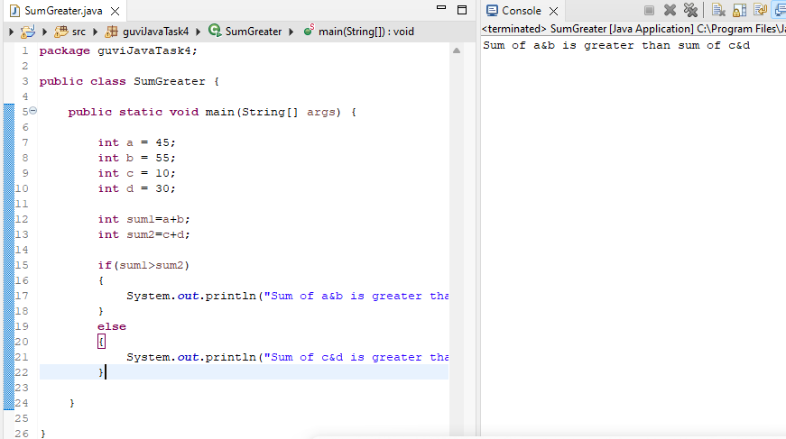

1. **Even or odd**

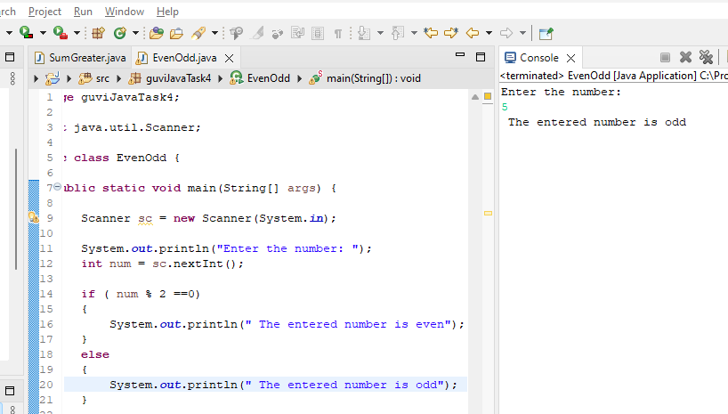

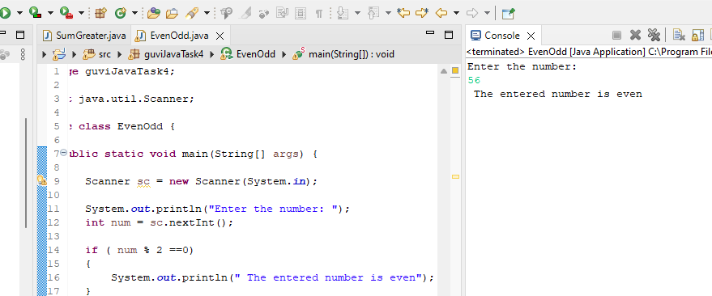

1. **Print A-Z**

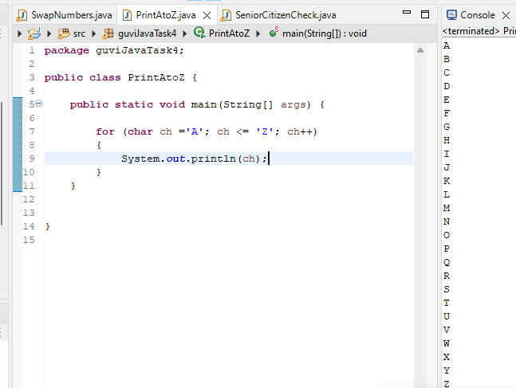

1. **Swap numbers**

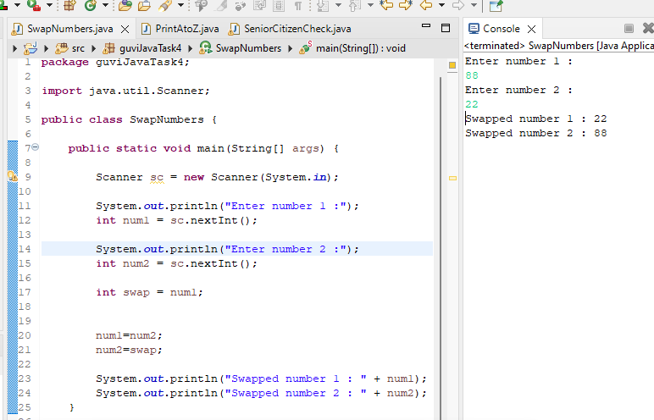

1. **Prime Number**
2. **Factorial of a number**

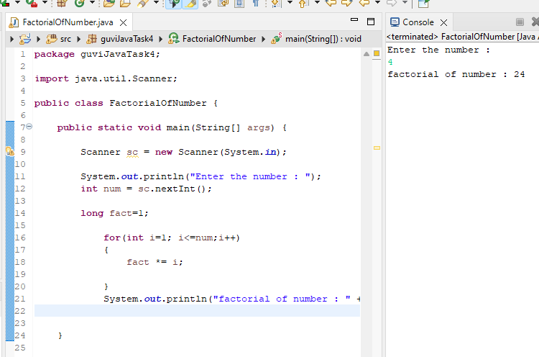

1. **Length of String**

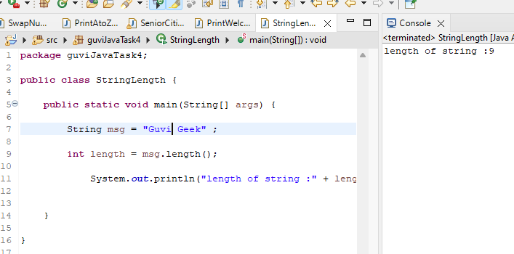

1. **Print Welcome Guvi**

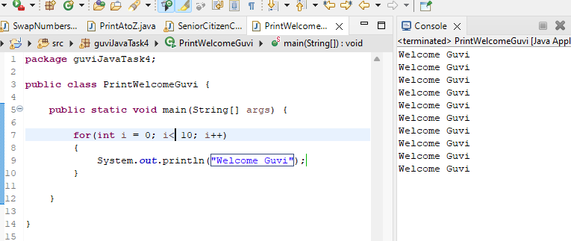

1. **Senior Citizen**

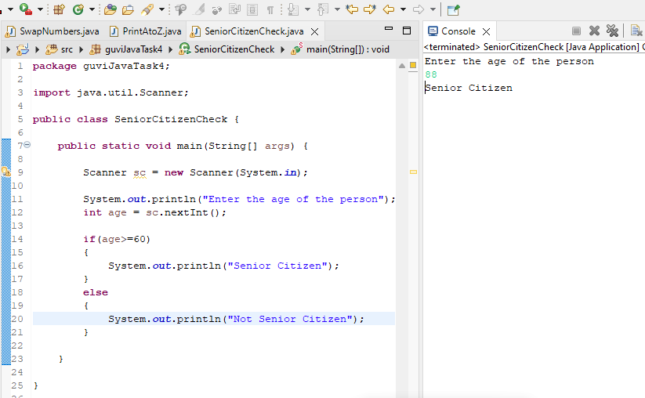

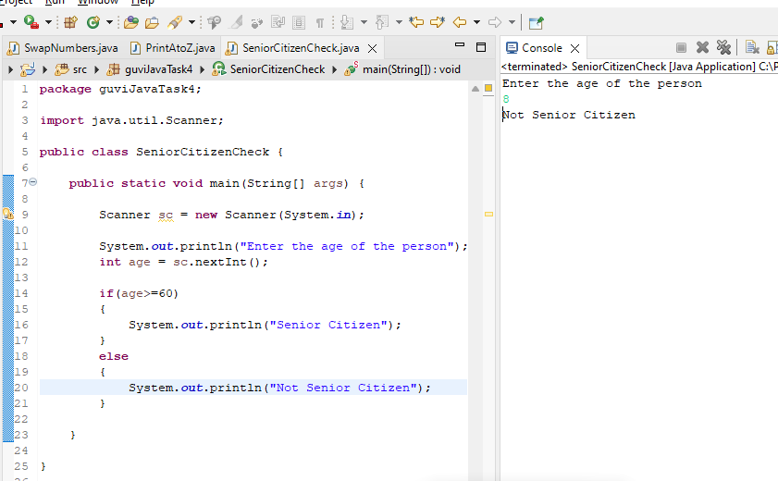

1. **Count Number of digits**